Week | Assignment | Using  Kit # | Forms due | Reports  due
1 | - | - | - | -
2 | 1B | 1 | C14, C16, C18, C20 | -
3 | 2A | 2 | C16, C18, C20, C25, C27, C29 | R1, R2
4 | 2B | 3 | C16, C18, C20, C25, C27, C29 | R3
5 | 3B | 4 | C16, C18, C20, C27, C29, C34, C37, C39 | -
6 | 4B | 5 | C16, C18, C20, C27, C29, C37, C39, C45, C47, C49 | -

Physical & Logical LOC Results

Program 1B
org.greg.drexel.b1.Main.java
- Physical LOC: 109
- Logical LOC: 32

org.greg.drexel.b1.gui.MainFrame.java
- Physical LOC: 296
- Logical LOC: 90

org.greg.drexel.b1.types.FileModeType.java
- Physical LOC: 32
- Logical LOC: 10

org.greg.drexel.b1.io.MyFileReader.java
- Physical LOC: 65
- Logical LOC: 13

org.greg.drexel.b1.io.MyFileWriter.java
- Physical LOC: 64
- Logical LOC: 12

Program 2A
org.greg.drexel.a2.loc.CountingStandard.java (Added from 1B)
- Physical LOC: 109
- Logical LOC: 33 (All 33 LOC added)

org.greg.drexel.a2.loc.LOCCounter.java (Added from 1B)
- Physical LOC: 87
- Logical LOC: 20 (All 20 LOC added)

org.greg.drexel.b1.Main.java (Modified from 1B)
- Physical LOC: 108
- Logical LOC: 41 (1B: 32, so 41-32 = 9 LOC added)

org.greg.drexel.b1.gui.MainFrame.java (Modified from 1B)
- Physical LOC: 174
- Logical LOC: 55 (1B: 90, so 90-55 = 35 LOC deleted)

org.greg.drexel.b1.io.MyFileReader.java (Untouched from 1B)
- Physical LOC: 65
- Logical LOC: 13 (Same LOC from 1B, untouched code)

org.greg.drexel.b1.io.MyFileWriter.java (Modified from 1B)
- Physical LOC: 64
- Logical LOC: 12 (Same LOC from 1B, only modified LOC)

Note: Completely removed org.greg.drexel.b1.types.FileModeType.java from 1B (10 LOC deleted)

Program 2B
org.greg.drexel.b1.Main.java (Modified from 1B)
- Physical LOC: 147
- Logical LOC: 46 (1B: 32, so 46-32 = 14 LOC added)

org.greg.drexel.b1.gui.MainFrame.java (Modified from 1B)
- Physical LOC: 478
- Logical LOC: 148 (1B: 90, so 148-90 = 58 LOC added)

org.greg.drexel.b1.io.MyFileReader.java (Untouched from 1B)
- Physical LOC: 65
- Logical LOC: 13 (Same LOC from 1B, untouched code)

org.greg.drexel.b1.io.MyFileWriter.java (Modified from 1B)
- Physical LOC: 64
- Logical LOC: 11 (1B: 12, so 12-11 = 1 LOC deleted)

org.greg.drexel.b1.types.FileModeType.java
- Physical LOC: 33
- Logical LOC: 11 (1B: 12, 1 LOC added)

org.greg.drexel.b1.types.FileModifyType.java (New in 2B)
- Physical LOC: 35
- Logical LOC: 13 (All 13 lines added, new class)

Program 3B
org.greg.drexel.b1.Main.java (Untouched from 2B)
- Physical LOC: 147
- Logical LOC: 46

org.greg.drexel.b1.gui.MainFrame.java (Modified from 2B)
- Physical LOC: 484
- Logical LOC: 151 (2B: 148, so 151-148 = 3 LOC added)

org.greg.drexel.b1.io.MyFileReader.java (Untouched from 2B)
- Physical LOC: 65
- Logical LOC: 13

org.greg.drexel.b1.io.MyFileWriter.java (Untouched from 2B)
- Physical LOC: 64
- Logical LOC: 11

org.greg.drexel.b1.types.FileModeType.java (Untouched from 2B)
- Physical LOC: 33
- Logical LOC: 11

org.greg.drexel.b1.types.FileModifyType.java (Untouched from 2B)
- Physical LOC: 35
- Logical LOC: 13

Program 4B
org.greg.drexel.b1.Main.java
- Physical LOC: 202
- Logical LOC: 68 (4+8+8+8=28 LOC added, 1 LOC modified, 3+3=6 LOC deleted)

org.greg.drexel.b1.gui.MainFrame.java
- Physical LOC: 511
- Logical LOC: 169 (18 LOC added, 1 LOC modified)

org.greg.drexel.b1.io.MyFileReader.java (Untouched from 3B)
- Physical LOC: 65
- Logical LOC: 13

org.greg.drexel.b1.io.MyFileWriter.java (Untouched from 3B)
- Physical LOC: 64
- Logical LOC: 11

org.greg.drexel.b1.types.FileModeType.java (Untouched from 3B)
- Physical LOC: 33
- Logical LOC: 11

org.greg.drexel.b1.types.FileModifyType.java (Untouched from 3B)
- Physical LOC: 35
- Logical LOC: 13

Totals
Program 1B
- Physical LOC: 626
- Logical LOC: 157
Program 2A
- Physical LOC: 607
- Logical LOC: 174
Program 2B
- Physical LOC: 822
- Logical LOC: 242
Program 3B
- Physical LOC: 828
- Logical LOC: 245
Program 4B
- Physical LOC: 910
- Logical LOC: 285

Note: Assignment 3B was SVN merged into Assignment 4B.
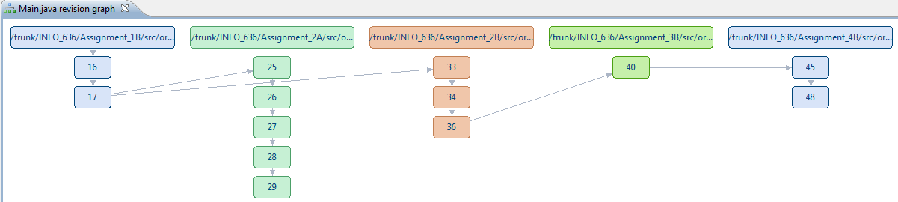
Program 4B Screenshots
Screenshots during testing

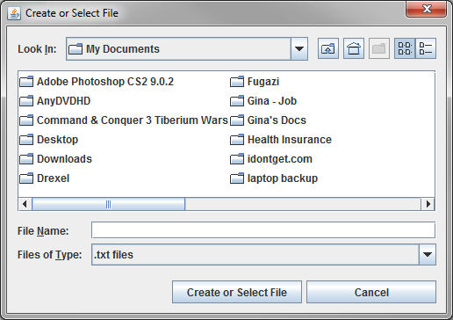
Figure 1. Normal startup screen

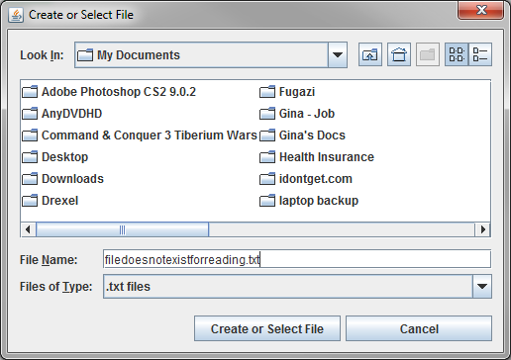
Figure 2. User enters file that does not exist

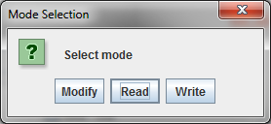
Figure 3. User selects Read mode

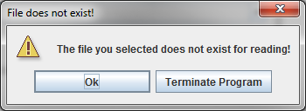
Figure 4. System informs users that selection was invalid

Figure 5. If "Ok" is selected, user is provided another opportunity to select a file for reading otherwise the program terminates

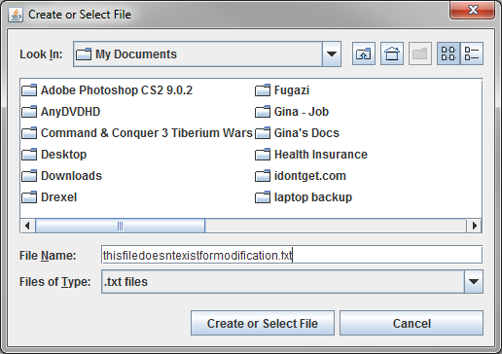
Figure 6. User enters file that doesn't exist

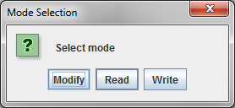
Figure 7. User selects Modify action

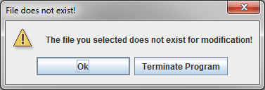
Figure 8. System informs user that the file doesn't exist

Figure 9. If "Ok" is selected, user is provided another opportunity to select a file for modification otherwise the program terminates

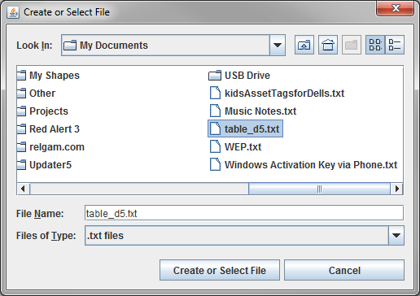
Figure 10. User selects an already existing file

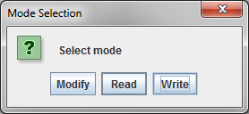
Figure 11. User selects Write mode

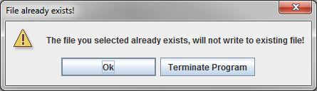
Figure 12. System informs users that it cannot write to existing file

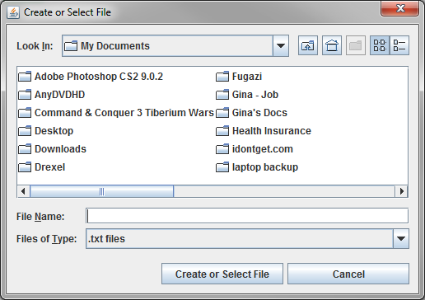
Figure 13. If "Ok" is selected, user is provided another opportunity to select a file for write operation otherwise the program terminates

Figure 14. Regression: User selects existing file

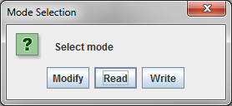
Figure 15. Regression: User selects Read mode

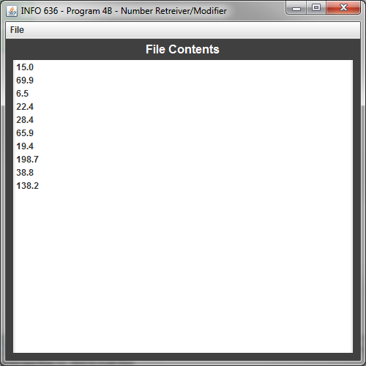
Figure 16. Regression: File contents are displayed

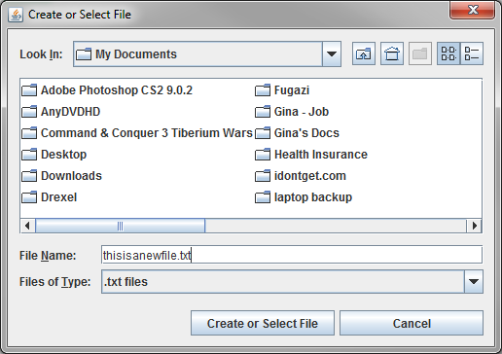
Figure 17. Regression: User types new file name

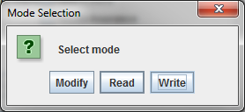
Figure 18. Regression: User selects Write mode

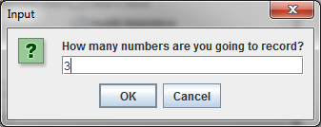
Figure 19. Regression: User elects to insert 3 numbers

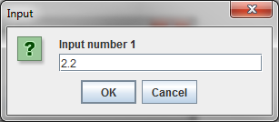
Figure 20. Regression: User inputs first number (of 3)

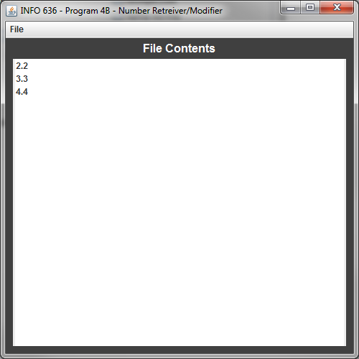
Figure 21. Regression: After all three numbers are inputted, contents are displayed

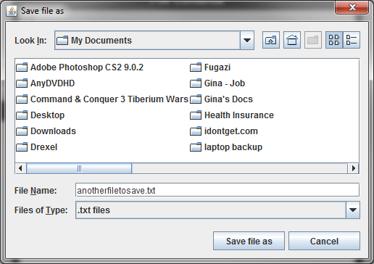
Figure 22. Regression: User selects Save As menu option

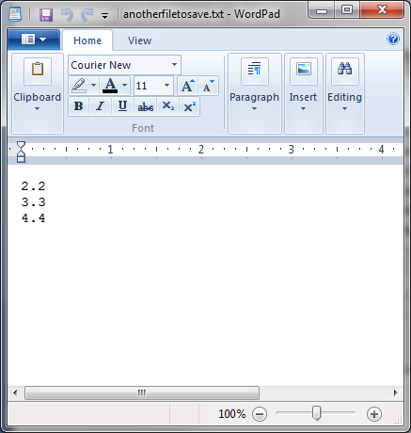
Figure 23. Regression: User saves old file as new file and opens contents in Wordpad

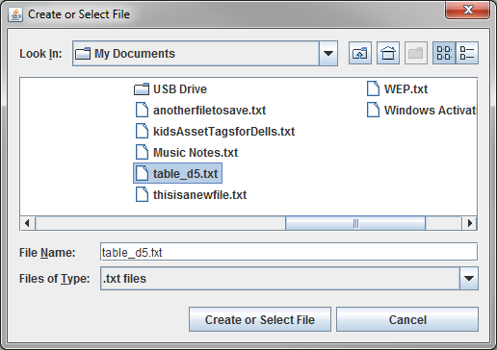
Figure 24. Regression: User selects exisitng file for modification

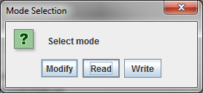
Figure 25. Regression: User selects modify mode

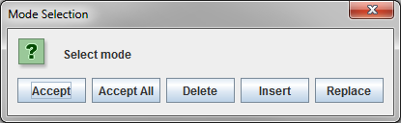
Figure 26. Regression: All modification modes are still available to user

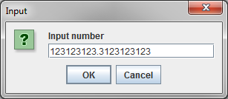
Figure 27. Regression: User elects to insert a new number

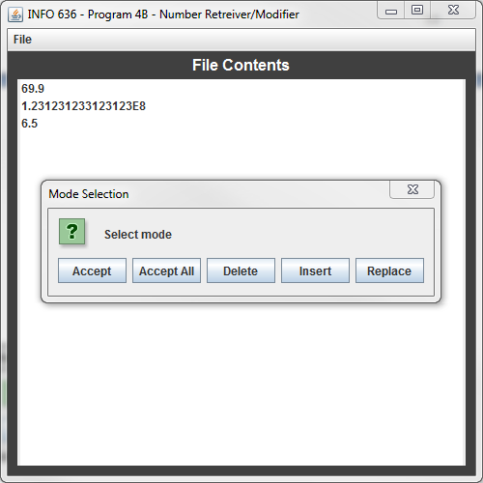
Figure 28. Regression: User's new number is displayed with same modification options as previous versions

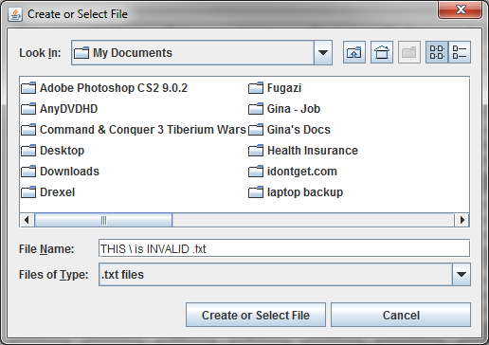
Figure 29. Still allows the user to save file as "is INVALID .txt" because of JFileChooser

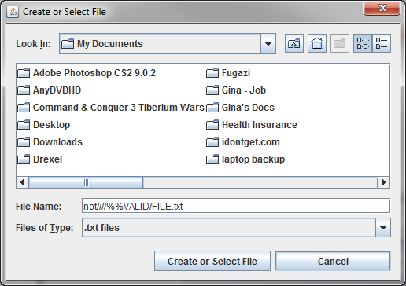
Figure 30. Still allows the user to save the file as "FILE.txt" because of JFileChooser

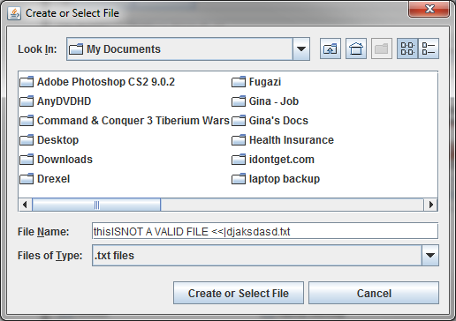
Figure 31. User enters invalid Windows filename value (/, \, :, *, ?, ", <, >, |)

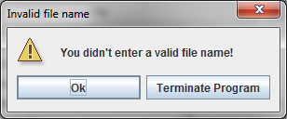
Figure 32. System tells users that filename was invalid

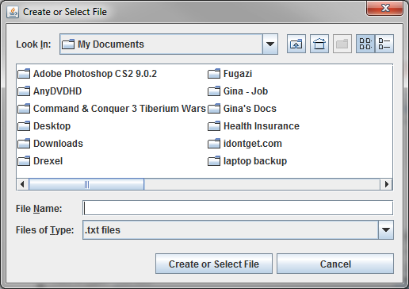
Figure 33. If user selects "Ok" they are presented with the file chooser, otherwise the system exists

It is important to note that JFileChooser will transcribe some user input (see Figure 29) although the user did not ask specifically for the result. JFileChooser is robust enough to eliminate some illegal special characters on-the-fly without developer or user involvement. The code was modified to add the illegal Windows characters for filenames (\ / : * ? " < > |), so when a user enters these characters within the filename, and JFileChooser does not automatically correct the result, the system will provide the user with a dialog box (see Figures 31 and 32).

Table C16: Time Recording Log

Student |  | Greg Vannoni |  |  |  |  | Date | 2/11/10
Instructor |  | Glenn Booker |  |  |  |  | Program # | 4B
Date | Start | Stop | Interruption  Time | Delta  Time | Phase | Comments
2/11 | 9:05p | 9:10p | 5 | 5 | PLAN | Made some tea
2/11 | 9:11p | 9:26p | 0 | 15 | DESIGN
2/12 | 8:50p | 9:30p | 6 | 34 | CODE | Nice and quick code changes
2/12 | 9:31p | 9:32p | 0 | 1 | COMPILE
2/13 | 5:20p | 5:25p | 0 | 5 | TEST | Leave for dinner
2/13 | 7:15p | 7:20p | 0 | 5 | TEST | All tests passed
2/14 | 7:00p | 7:30p | 0 | 30 | PM | Starting all the other paperwork!
2/15 | 7:15p | 8:20p | 5 | 60 | PM | Trying to figure out some of the new forms for most of this time
2/16 | 4:00p | 4:45p | 5 | 40 | PM | Finally done with tables and stuff!

Table C18 Defect Recording Log
Defect Types
10 Documentation 60 Checking
20 Syntax 70 Data
30 Build, Package 80 Function
40 Assignment 90 System
50 Interface 100 Environment
Student |  |  |  | Greg Vannoni |  |  |  |  |  |  |  | Date |  | 2/11/10
Instructor |  |  |  | Glenn Booker |  |  |  |  |  |  |  | Program # |  | 4B
Date |  | Number |  |  |  | Type |  | Inject |  | Remove |  |  | Fix Time |  | Fix Defect
2/13 |  | 1 |  |  |  | 50 |  | code |  | test |  |  | 5
 |  |  | Was not re-presenting the user with a file chooser if they didn't select the proper file
for read, write, modify. Had to make getFileLocation within Main.java so I could call it a numerous
amount of times if the user keeps selecting the incorrect file
Date |  | Number |  |  |  | Type |  | Inject |  | Remove |  |  | Fix Time |  | Fix Defect
2/13 |  | 2 |  |  |  | 60 |  | code |  | test |  |  | 3
Description: |  |  | Was comparing a Char to a String when determining a valid file that cannot have
\ / : * ? " < > or | in the filename (Windows convention)
Date |  | Number |  |  |  | Type |  | Inject |  | Remove |  |  | Fix Time |  | Fix Defect
Description:
Date |  | Number |  |  |  | Type |  | Inject |  | Remove |  |  | Fix Time |  | Fix Defect
Description:
Date |  | Number |  |  |  | Type |  | Inject |  | Remove |  |  | Fix Time |  | Fix Defect
Description:
Date |  | Number |  |  |  | Type |  | Inject |  | Remove |  |  | Fix Time |  | Fix Defect
Description:
Date |  | Number |  |  |  | Type |  | Inject |  | Remove |  |  | Fix Time |  | Fix Defect
Description:

Table C27 Process Improvement Proposal (PIP)

Student | Greg Vannoni |  | Date | 2/11/10
Instructor | Glenn Booker |  | Program # | 4B
Process | PSP1.1 | Elements

PIP Number
 |  | Problem Description:
1 |  | The number of things we now have to do is beginning to become cumbersome. It's getting harder and harder to figure out which form I start with.
PROPOSAL
PIP # |  | Proposal Description
1 |  | Always fill out the time recording log. It may be a good idea to start with C39 as this will give the basis for code estimation. Use C39 C45, C47 and C49 with your estimates and work from there.
Notes and Comments:
 |  | The addition of C47 and C49 threw a wrench in my routine. I
 |  | really had to spend some time figuring out how these two forms fit
 |  | into what I've already been doing. I did notice that they really do
 |  | help to determine schedule and the percentage completion. If we
 |  | aren't already doing something like this at work, we should be!

Table C37 Test Report Template

Student | Greg Vannoni | Date | 2/11/10
Instructor | Glenn Booker | Program # | 4B

Test Name/Number | Read functionality
Test Objective | Determine if there has been regression to Read functionality and determine if error checking is performed on the selected file
Test Description | This function has not changed since Program 3B, ensure
 | ensure that the user can still read the file like in 3B, also
 | ensure that if the user enters a file that doesn't exist, they
 | are given an error message
Test Conditions | 1. File may already exist with real numbers
Expected Results | 1. File selected and displayed in JList just like in
 | Program 3B
 | 2. Non-existent file is selected, user is presented with error dialog explaining the situation and may either continue (by selecting an existing file) or terminate the program
Actual Results | Success. Program displayed file just like Program 3B.
 | When an invalid file was selected, user was presented
 | with dialog box as described in expected results.
Test Name/Number | Write functionality
Test Objective | Ensure write functionality from 3B still exists and that a warning message is displayed when the user attempts to write to a file that already exists.
Test Description | 1. Ensure that write functionality has not regressed since 3B
 | 2. Ensure that new warning dialog box is displayed
 | when a number is not properly input to system.
 | 3. Ensure that a dialog box is presented to the user when they select a file that already exists.
Test Conditions | None
Expected Results | 1. File should be written to selected directory just like 3B
 | 2. If invalid input is given, a dialog box should appear that allows the user to continue (retry) or exit the application.
 | 3. If the user selects an already existing file, a dialog box should appear which will allow the user to continue (by re-entering another non-existent file) or terminate the program
Actual Results | Success. No regression to write capability, dialog box with
 | "Ok" and "Terminate Application" are displayed when
 | invalid number (integer when asked for quantity of
 | numbers and double/real number when asked for number
 | input.
Test Name/Number | Modify functionality
Test Objective | Ensure that there has been no regression in modify functionality and that the user can only select from the options in program 3B.
Test Description | 1. Validate that no functionality has changed since 3B
 | 2. Select the "Insert" button after the "Modify" mode is selected and validate that invalid number input (for real numbers) has the Program 4B warning message to the user.
 | 3. Ensure that when the user selects a non-existent file to modify they are presented with a dialog box in which they can continue or terminate the application
Test Conditions | User must select "Modify" mode to be presented with
 | modify functionality
Expected Results | 1. If the user selects the "Insert" mode, and inserts a non-real number, a warning dialog should be displayed.
 | 2. All existing 3B functionality for Accept, Accept All, Replace and Delete should exist unmodified.
 | 3. If a user selects a file that doesn't exist for modification, they should be presented with a dialog box which will allow them to continue (select another file to modify) or terminate the application.
Actual Results | Successful, all tests passed.
Test Name/Number | File name validity check
Test Objective | Ensure the filename a user selects is valid (per Windows filename validity checks)
Test Description | 1. If a user inputs the characters \ / : * ? " < > |, a dialog box should be displayed to inform the user of an invalid file name.
Test Conditions | Java's JFileChooser may auto-correct some filenames, however, in most cases, any filename with the invalid characters as stated above should be caught.
Expected Results | 1. If the user has any characters listed above in the filename, it should be treated as invalid alerting the user as such.
Actual Results | Successful, all tests passed.

Table C39 Size Estimating Template
SEE SPREADSHEET(4BVannoniEstimations.xls) FOR CALCULATIONS

Table C45 PSP1.1 Project Plan Summary

Student | Greg Vannoni | Date | 2/11/10
Program |  | Program # | 4B
Instructor | Glenn Booker | Language | Java

Summary | Plan |  |  |  | Actual |  |  |  | To Date
LOC/Hour | 20 |  |  |  | 43/(195/60) = 13.23 |  |  |  | 12.86+13.23/2 = 13.045
Planned Time | 196* |  |  |  |  |  |  |  | 196
Actual Time |  |  |  |  | 195 |  |  |  | 195
CPI(To Date Planned Time)/(To Date Actual Time) |  |  |  |  |  |  |  |  | 1.005
 |  |  |  |  |  |  |  |  | (Planned/Actual)
% Reused | 5% |  |  |  | R/N = 5/43 = 11.62% |  |  |  | 11.62%
% New Reused (Reusable) | 1% |  |  |  | 4/43 = 9.3% |  |  |  | 9.3%
Program Size (LOC): | Plan |  |  |  | Actual |  |  |  | To Date
Base(B) | 245 |  |  |  | 245
 | (Measured) |  |  |  | (Measured)
Deleted (D) | 6 |  |  |  | 6
 | (Estimated) |  |  |  | (Counted)
Modified (M) | 4 |  |  |  | 2
 | (Estimated) |  |  |  | (Counted)
Added (A) | 41 |  |  |  | 41
 | (N-M) |  |  |  | (T-B+D-R)
Reused (R) | 2 |  |  |  | 5 |  |  |  | 20+5=25
 | (Estimated) |  |  |  | (Counted)
Total New & Changed (N) | 45 |  |  |  | 43 |  |  |  | 197+43=240
 | (Estimated) |  |  |  | (A+M)
Total LOC (T) | 282 |  |  |  | 285 |  |  |  | 661+285=946
 | (N+B-M-D+R) |  |  |  | (Measured)
Total New Reused (Reusable) | 4 |  |  |  | 4 |  |  |  | 70+4=74
Time in Phase (min.) | Plan |  | Actual |  |  |  | To Date |  |  |  | To Date %
Planning | 10 |  | 5 |  |  |  | 50+5=  55 |  |  |  | 3.72%
Design | 15 |  | 15 |  |  |  | 60+15=  75 |  |  |  | 5.07%
Code | 30 |  | 34 |  |  |  | 554+34=  588 |  |  |  | 39.78%
Compile | 1 |  | 1 |  |  |  | 8+1=  9 |  |  |  | 0.61%
Test | 20 |  | 10 |  |  |  | 124+10=  134 |  |  |  | 9.07%
Postmortem | 120 |  | 130 |  |  |  | 487+130=617 |  |  |  | 41.74%
Total | 196 |  | 195 |  |  |  | 1478 |  |  |  | 100%
(continued)

Because I got lucky with time estimation this week, my CPI is really close to 1.0. I doubt this will continue this way next week as I start using the time estimation from C39 along with C47 and C49.
Table C45 PSP1.1 Project Plan Summary (continued)

Student | Greg Vannoni | Date | 2/11/10
Program |  | Program # | 4B
Instructor | Glenn Booker | Language | Java

Defects Injected |  |  | Actual |  | To Date |  | To Date %
Planning |  |  |  |  | 5 |  | 33.33%
Design |  |  |  |  | 3 |  | 20%
Code |  |  | 2 |  | 7 |  | 46.66%
Compile |  |  |  |  | 0 |  | 0%
Test |  |  |  |  | 0 |  | 0%
Total Development |  |  |  |  | 15 |  | 100%
Defects Removed |  |  | Actual |  | To Date |  | To Date %
Planning |  |  |  |  | 0 |  | 0%
Design |  |  |  |  | 1 |  | 6.67%
Code |  |  |  |  | 4 |  | 26.67%
Compile |  |  |  |  | 0 |  | 0%
Test |  |  | 2 |  | 10 |  | 66.67%
Total Development |  |  |  |  | 15 |  | 100%
After Development |  |  | 0 |  | 0

*Note: The Planned Time used for this spreadsheet was not based from C39, instead C47 and C49 were used to plan the time I thought I would have to do each task. In the next assignment, I will use the estimated value from C39 and reverse engineer the time it will take me to complete each task. I honestly have no idea how I came so close to the actual time spent on this project, I doubt I will get this close using the C39 chart with a range of 555.59 minutes and a variance of 158818 with standard deviation of 398.52 there's no telling how far off my estimates will be for the next assignment!
Table C47 Task Planning Template

Student | Greg Vannoni | Date | 2/11/10
Project | 4B | Instructor | Booker

Task |  | Plan |  |  |  |  | Actual
# | Name | Mins | Planned Value | Cumulative  Mins | Cumulative Planned  Value | Date | Date | Earned Value | Cumulative Earned Value
1 | Planning | 10 | 1.5 | 10 | 1.5 | 2/11 | 2/11 | 1.5 | 1.5
2 | Design | 15 | 3.5 | 25 | 5 | 2/11 | 2/11 | 3.5 | 5
3 | Code | 30 | 10.0 | 55 | 15 | 2/12 | 2/12 | 10 | 15
4 | Compile | 1 | 0.5 | 56 | 15.5 | 2/13 | 2/12 | 0.5 | 15.5
5 | Test | 20 | 15.0 | 76 | 30.5 | 2/13 | 2/13 | 15 | 30.5
6 | Post-Mortem | 120 | 20.0 | 196 | 50.5 | 2/15 | 2/15 | 0 | 30.5
 |  |  |  |  |  |  | 2/16 | 20 | 50.5
Totals |  | 196 | 50.5

Table C49 Schedule Planning Template

Student | Greg Vannoni | Date | 2/11/10
Project | 4B | Instructor | Booker

 |  | Plan |  |  | Actual
Day | Date | Direct | Cumulative | Cumulative | Direct | Cumulative | Cumulative | Adjusted
No. |  | Mins | Mins | Planned Value | Mins | Mins | Earned Value | Earned Value
1 | 2/11 | 30 | 30 | 5 | 20 | 20 | 5
2 | 2/12 | 30 | 60 | 15 | 35 | 55 | 15.5
3 | 2/13 | 40 | 100 | 30.5 | 10 | 65 | 30.5
4 | 2/14 | 60 | 160 | 30.5 | 30 | 95 | 30.5
5 | 2/15 | 60 | 190 | 50.5 | 60 | 155 | 30.5
6 | 2/16 | 10 | 200 |  | 40 | 195 | 50.5

